FSC Canada Standards Revision Process
Call for Technical Experts

Introduction
FSC Canada is looking for technical experts to assist with the development of the Canadian Forest Management (FM) Standard in five key thematic areas noted below. Several positions with corresponding qualifications are required.

Background
Beginning in late 2012, FSC Canada launched the process to revise and align of Canada’s regional FM Standards (National Boreal Standard (2004), Maritimes Standard (2008), BC Standard (2005) and Great Lakes-St. Lawrence draft Standard (2010)) with the revised Principles and Criteria and the International Generic Indicators.

The revision of the Forest Management (FM) Standards will strive to build on previous work and agreements while providing opportunities for focused regional and national discussions.

FSC Canada aims to have the Forest Management Standard submitted for approval, to FSC International, by December 31, 2015.

Addressing Key Indicators and Themes
In carrying out this important work, FSC Canada has surveyed stakeholders and conducted a review to identify indicators and themes that require more active discussion from stakeholders and experts.

From this survey, six key thematic areas emerged, including:
- Species at Risk (Woodland Caribou)
- Principle 6, 9 and 10 (from the new Principles & Criteria - v.5): Ecological & Operational Consideration
- Principle 3: Aboriginal Rights, including Free, Prior and Informed Consent
- Community and Stakeholder Rights (legal and customary)
- Scale, Intensity and Risk (SIR), including Small and Low Intensity Managed Forests (SLIMF)
- Pesticides, Conversion and Invasive Species
To oversee the standards revision process including addressing the key themes, FSC Canada has put together a chamber balanced Standards Development Group who provide strategic direction for the new Forest Management Standard in Canada and who are now looking to put together a series of Technical Expert Panels (TEP) to provide science-based and technical guidance and recommendations.

Technical Expert Panels
There will be a total of 6 voluntary Technical Expert Panels which will provide technical guidance and recommendations to FSC Canada to be considered when developing normative measures (e.g. indicators and supplementary materials where needed). The guidance and recommendations will be used to inform the National Standard revision process.
The TEP on Species at Risk has already been formed. Below is an example of its structure:
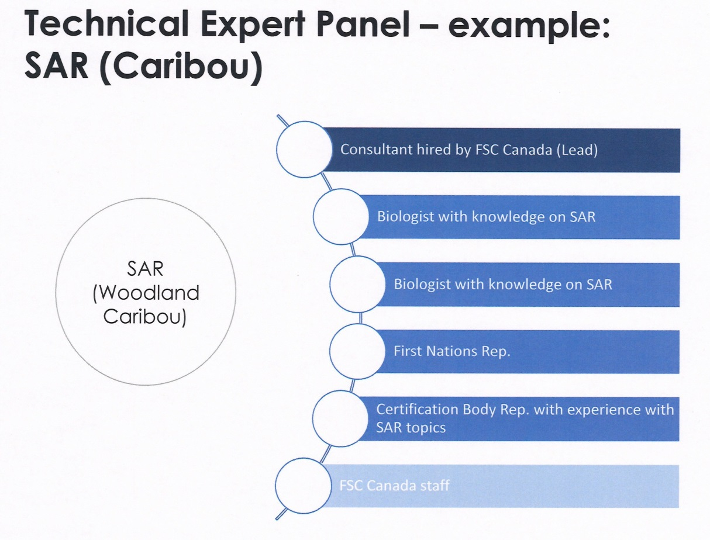
FSC Canada is now seeking voluntary participants for the following Technical Expert Panels (TEPs):
- Principle 6, 9 and 10 (from the new Principles & Criteria - v.5): Ecological & Operational Consideration:
- Principle 3: Aboriginal Rights, including Free, Prior and Informed Consent
- Community and Stakeholder Rights (legal and customary)
- Scale, Intensity and Risk (SIR), including Small and Low Intensity Managed Forests (SLIMF)
- Pesticides, Conversion and Invasive Species

Responsibilities
A detailed Terms of Reference will be provided to each Technical Expert Panel.
- Proposing solutions and recommendations on how to address indicators and guidance documents;
- Presenting recommendations to the Standards Development Group and FSC Canada Standards Board Committee for review & discussion;
- Seeking additional expertise as needed.

Eligibility
- Knowledge and expertise related to the topic of study;
- Knowledge and expertise in forest certification and best-audit practices and standards setting;
- Scientists, auditors and/or practioners who have published peer-reviewed works related to the topics of study and /or who have extensive experience and are well-respected in their field;
- Familiarity with the FSC Canada’s Forest Management Standards and the FSC certification system is an asset.

Other Considerations
- This is a voluntary position;
- Working language will be English;
- Technical Expert Panels will not require chamber balance. The panels will be made up of experts who reflect a diversity of perspectives;
- Consideration will be given to a range in regional representation;
- Members of the Standards Development Group may be considered for TEP.

Time Commitment
- Participants should expect to participate on approximately 2-3 calls between April to August 2014 with some emails exchanges in between.

Apply to be on an Expert Panel
Several positions with corresponding qualifications are required based on each topic of study. Please use the following tables to see what is available and to submit your name for the appropriate position.

PLEASE FILL OUT AND SUBMIT TO v.peachey@ca.fsc.org by Friday April 4, 2014

Ecological & Operational Consideration: Principle 6, 9 and 10 (v.5)
Considerations: Ecological and operational consideration that may include benchmarking forest conditions, restoration, climate change, forest retention, intact forest landscapes/core habitats, High conservation values including old growth forests, protected areas and implementation of operational plan/silviculture.
Position | Name & Position  Brief description of Qualifications  Contact Details
- Environment chamber representative with ecological &/or operational experience
- Forest industry representative with ecological &/or operational experience
- Biologist working with industry with ecological &/or operational experience
- Eminent biologist with ecological &/or operational experience
- FSC ecological and operational auditor

Principle 3: Aboriginal Rights, including Free, Prior and Informed Consent
Considerations: As part of a global project that seeks to better understand the past and future application of P3 and FPIC in the Canadian context. The work and discussions conducted in that project will serve to inform the role of FPIC and its application in our National Standard.
Position | Name & Position  Brief description of Qualifications  Contact Details
- Eminent social scientist with policy and operations experience
- Large scale forest industry representative with experience in Aboriginal Rights
- Eminent lawyer or social scientist with experience with Aboriginal Rights
- FSC auditor with experience in auditing Principle 3

Community and Stakeholder Rights
Considerations: Understand and define the legal or customary rights of local communities, who have Free, Prior and Informed Consent and the application of stakeholders engagement in a Canadian context.
Position | Name & Position  Brief description of Qualifications  Contact Details
Eminent social scientist with policy and operation experience (1-2 people)
FSC auditor with experience in auditing social issues
Forest industry representative with experience in stakeholder and community rights

Scale, Intensity and Risk (SIR), including SLIMF
Considerations: How to apply the concept of SIR to operations of different sizes and how to make a viable standard while reaching the objectives of the FSC Principle & Criteria for smaller operations.
Position | Name & Position  Brief description of Qualifications  Contact Details
Small scale forest management representative (SLIMF: woodlot management, community & group experience) (1-2 people)
Small to mid-size industry representative (SIR)
Eminent social scientist or lawyer with experience with SLIMF, community and small-mid size forest management operations
FSC auditor with experience in auditing community, SLIMF &/or groups

Pesticides, Conversion and Invasive Species
Considerations: Several considerations related to the use of pesticides (mainly herbicides), conversion, the use of exotic species and invasive species.
Position | Name & Position  Brief description of Qualifications  Contact Details
- Representative with silviculture and operation experience
- Environment chamber representative with ecological &/or operational experience
- Eminent Biologist with ecological &/or operational experience
- FSC ecological and operational auditor

